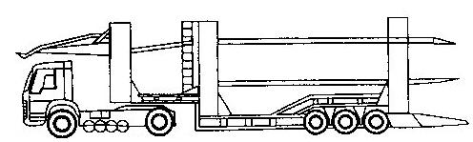
Grayline Transport Limited

Langmuir Way
Langmuir Road
Bargeddie
G69 7RW
Tel: 0141 773 3700
Fax: 0141 773 3233

office@graylinetransport.co.uk
www.graylinetransport.co.uk

VEHICLE TRANSPORT REQUEST FORM

VEHICLE REGISTRATION / CHASSIS NO
VEHICLE MAKE & MODEL
COLLECTION ADDRESS INCL POSTCODE & TELE NO

CONTACT NAME
DELIVERY ADDRESS INCL POSTCODE & TELE NO

CONTACT NAME
BOOKING REF
PRICE AGREED
ORDER NO
DELIVERY DATE / DEADLINE
INVOICE TO

